Order Of Service

Singing: Psalm 65—CW page 89

Reading: Psalm 111

Opening Hymn: TLH 285

Reading: Acts 27:27-32

Request Hymn: CW Supplement 749

Reading: Matthew 12:46-50

Sermon Hymn: TLH 200 vs 1-4

Sermon Text: Mark 12:18-27

The God Of The Living

Prayer

The Apostles’ Creed, TLH page 12

Holy Communion

The Lord's Prayer

The Blessing

Closing Hymn: TLH 200 vs 5-8

* * * * * * * * * * *

Bible Study: Lambs: Black-Headed Gull
Sheep: Proverbs 22:6-10
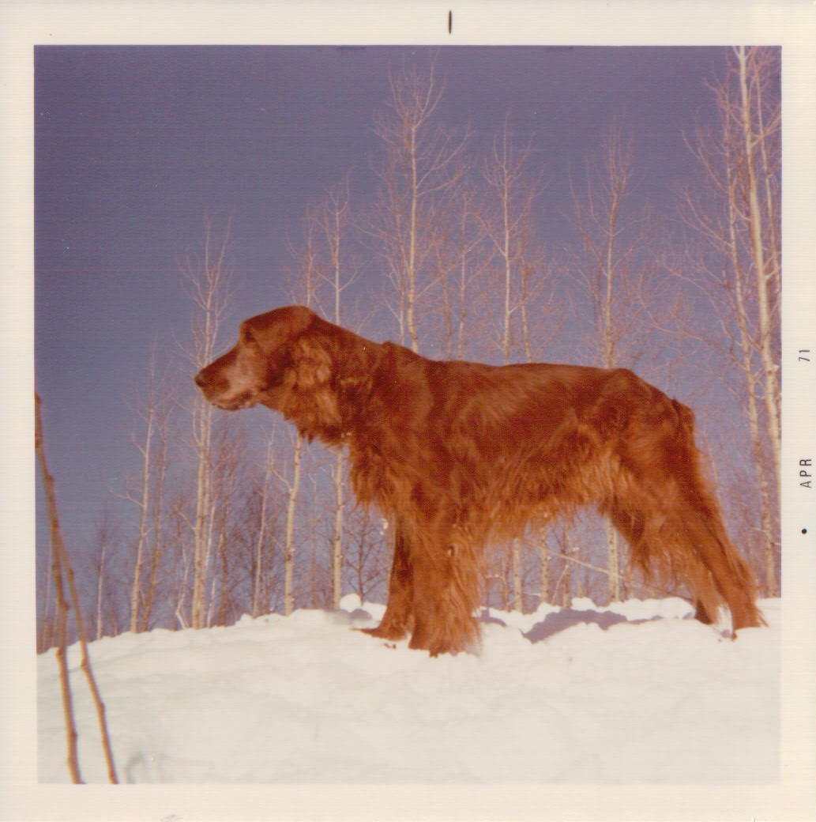

Auburn Artistry

Water
Of
Life

26 January 2020

W A T E R O F L I F E

Independent Christian Church—Conservative Lutheran Doctrine

Worship Service: 9:30 a.m. Bible Study: 10:45 a.m.

Larry Cooper, Pastor E-Mail address:
111 N. Ridge Road lcooper@wateroflife.cc
Coon Valley, WI 54623 Web Site:
www.wateroflife.cc

* * * * * * * * * * * * * * * * * * * * * * * * * * *

Sermon Text: Mark 12:18-27

The God Of The Living

* * * * * * * * * * * * * * * * * * * * * * * * * * *

Mark 12:18 Then come unto him the Sadducees, which say there is no resurrection; and they asked him, saying,
:19 Master, Moses wrote unto us, If a man's brother die, and leave his wife behind him, and leave no children, that his brother should take his wife, and raise up seed unto his brother.
:20 Now there were seven brethren: and the first took a wife, and dying left no seed.
:21 And the second took her, and died, neither left he any seed: and the third likewise.
:22 And the seven had her, and left no seed: last of all the woman died also.
:23 In the resurrection therefore, when they shall rise, whose wife shall she be of them? for the seven had her to wife.
:24 And Jesus answering said unto them, Do ye not therefore err, because ye know not the scriptures, neither the power of God?
:25 For when they shall rise from the dead, they neither marry, nor are given in marriage; but are as the angels which are in heaven.
:26 And as touching the dead, that they rise: have ye not read in the book of Moses, how in the bush God spake unto him, saying, I am the God of Abraham, and the God of Isaac, and the God of Jacob?
:27 He is not the God of the dead, but the God of the living: ye therefore do greatly err.

